SPRINT - 1
DATE: | 27-10-2022
TEAM ID: | PNT2022TMID26590
PROJECT NAME: | SIGNS WITH SMART CONNECTIVITY FOR BETTER ROAD SAFETY

SPRINT GOALS:

1. Create and initialize accounts in various public APIs like OpenWeather API.
2. Write a Python program that outputs results given the inputs like weather and location.

CODE FLOW:
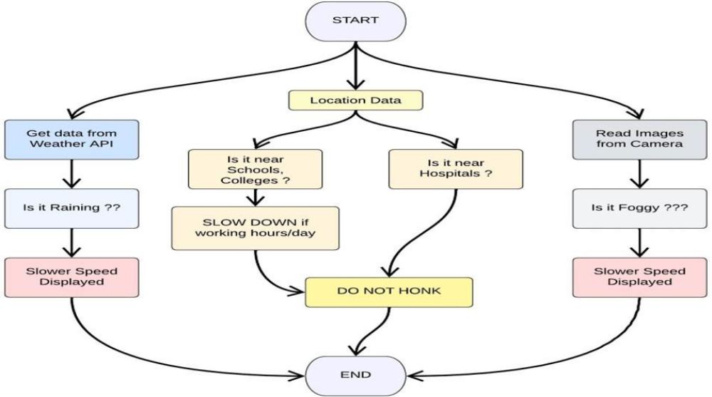
PROGRAM CODE:
Weather.py

This file is a utility function that fetches the weather from OpenWeatherAPI. It returns only certain required parameters of the API response.

# Python code
import requests as reqs
def get(myLocation,APIKEY): apiURL = f"https://api.openweathermap.org/data/2.5/weather?q={myLocation}&appid={API KEY}"
responseJSON = (reqs.get(apiURL)).json() returnObject = {
"temperature" : responseJSON['main']['temp'] - 273.15,
"weather" : [responseJSON['weather'][_]['main'].lower() for _ in range(len(responseJSON['weather']))],
"visibility" : responseJSON['visibility']/100, # visibility in percentage where 10km is 100% and 0km is 0%
}
if("rain" in responseJSON):
returnObject["rain"] = [responseJSON["rain"][key] for key in responseJSON["rain"]]
return(return)

Objectbrain.py

This file is a utility function that returns only essential information to be displayed at the hardware side and abstracts all the unnecessary details. This is where the code flow logic is implemented.

# Python code
# IMPORT SECTION STARTS
import weather
from datetime import datetime as dt
# IMPORT SECTION ENDS
# # UTILITY LOGIC SECTION STARTS
def processConditions(myLocation,APIKEY,localityInfo): weatherData = weather.get(myLocation,APIKEY)
finalSpeed = localityInfo["usualSpeedLimit"] if "rain" not in weatherData else localityInfo["usualSpeedLimit"]/2
finalSpeed = finalSpeed if weatherData["visibility"]>35 else finalSpeed/2
if(localityInfo["hospitalsNearby"]): # hospital zone
doNotHonk = True else:
if(localityInfo["schools"]["schoolZone"]==False): # neither school nor hospital zone doNotHonk = False else:
# school zone
now = [dt.now().hour,dt.now().minute] activeTime = [list(map(int,_.split(":"))) for _ in
localityInfo["schools"]["activeTime"]]
doNotHonk = activeTime[0][0]<=now[0]<=activeTime[1][0] and activeTime[0][1]<=now[1]<=activeTime[1][1]
return({
"speed" : finalSpeed, "doNotHonk" : doNotHonk
})
# UTILITY LOGIC SECTION ENDS

Main.py

The code that runs in a forever loop in the microcontroller. This calls all the util functions from other python files and based on the return value transduces changes in the output hardware display.
# Python code
# IMPORT SECTION STARTS
import brain
# IMPORT SECTION ENDS
# # USER INPUT SECTION STARTS
myLocation = "Chennai,IN"
APIKEY = "bf4a8d480ee05c00952bf65b78ae826b"
localityInfo = { "schools" : {
"schoolZone" : True,
"activeTime" : ["7:00","17:30"] # schools active from 7 AM till 5:30 PM
},
"hospitalsNearby" : False, "usualSpeedLimit" : 40 # in km/hr
}
# USER INPUT SECTION ENDS
# # MICRO-CONTROLLER CODE STARTS
print(brain.processConditions(myLocation,APIKEY,localityInfo))
''' MICRO CONTROLLER CODE WILL BE ADDED IN SPRINT 2 AS PER OUR PLANNED SPRINT SCHEDULE '''
# MICRO-CONTROLLER CODE ENDS

OUTPUT:
# Code Output
{'speed': 40, 'doNotHonk': False}
IMAGES:
